Title: BMart Design Document
Author: Jonathon Youngquist, Kevin Zhang, Ryan Wang, Edwin He, Eric Liu, David Lin, Michael Zhou
Reviewers: Joshua Zhang
Last Updated: March 9, 2025

Overview
This is a Design for BMart, an online marketplace designed for access via the web using React, Next, and Firebase, designed to connect buyers and sellers through a trusted platform.

Introduction
Current online marketplace systems (namely Facebook Marketplace and MySchoolMarket) possess clear problems that BMart seeks to address. Facebook Marketplace lacks moderation of postings, allowing fencing of stolen goods, and has a poor rating system which requires multiple steps to check a user’s rating before seeking to purchase, or accepting a buyer’s requests. MySchoolMarket is lacking a rating system entirely, and while it does have a system to report postings, it needs improvement. BMart aims to address both of these concerns with an easy, integrated rating system with user ratings visible in both sale listings and purchase requests, along with an easy system to report postings for takedown.
BMart also seeks to provide a market for Bruins, by Bruins, similar to MySchoolMarket, unlike the broad, unmoderated environment of Facebook Marketplace.

Goals
- Design an approachable, inviting online marketplace
- Support up to 100+ concurrent users with <5s response time
- Search functionality for listings
- Enable buyers and sellers to connect and rate each other

Non-Goals:
- Mobile app implementation (possible future expansion)
- Machine learning features / sale recommendations
- Direct payment between users
- Live chat room

Core Components

1. Frontend Service
- React SPA with TypeScript
- State management: UseState
- Component library: Material UI

2. API Gateway
- Next.js
- Interfaces: user account API, sales listing API, search service

3. Backend Service
- Database: Firebase/Firestore
- Security: Firebase/auth
- Storage: Firebase/storage

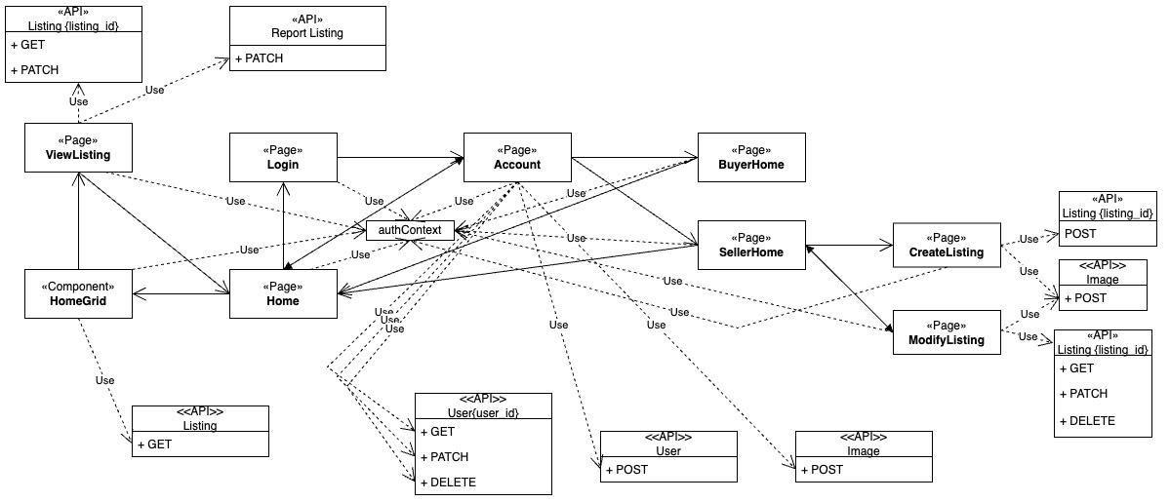
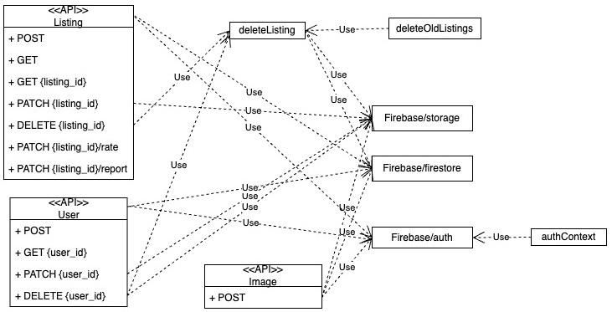
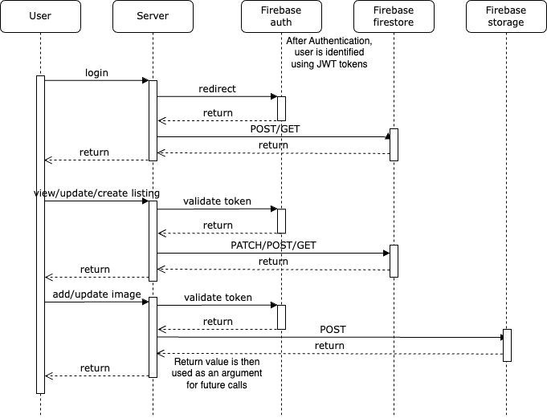

Data Models
user |  | Example: users/example-user-id  {  “first”: “Joe”,  “last”: “Bruin”,  “email_address”: “joebruin@g.ucla.edu”,  “phone_number”: “3108254321”,  “active_listings”:[  “listing1”, “listing2”, “listing3”, “listing4”  ],  “interested_listings”:[  “listing5”, “listing6”, “listing7”, “listing8”  ],  “completed_sales”: 53,  “completed_purchases”: 101,  “cum_buy_rating”: 467,  “cum_seller_rating”: 250,  “pfp”: “https://firebasestorage.googleapis.com/v0/…”  “last_reported”: March 9, 2025 at 11:40:05 AM UTC-7  }
first | string
last | string
email_address | string
phone_number | string
active_listings | [string]
interested_listings | [string]
completed_sales | number
completed_purchases | number
cum_buyer_rating | number
cum_seller_rating | number
pfp | string
last_reported | Timestamp

listing |  | Example: listings/example-listing-id  {  “updated”: March 8, 2025 at 2:06:11 PM UTC-7,  “price”: 870,  “condition”: “USED”,  “category”: “ELECTRONICS”,  “description”: “old macbook pro, factory reset”,  “owner”: “owner-user-id”,  “selected_buyer”: “buyer-user-id”,  “potential_buyers”: [  “buyer-user=id”, “potential-1”, “potential-2”  ],  “reporters”: [  “reporter-1”, “reporter-2”  ],  “ratings”: {  “owner-user-id”: 5,  “buyer-user-id”: 4,  },  “image_paths”: [  “https://firebasestorage.googleapis.com/v0/…”,  “https://firebasestorage.googleapis.com/v0/…”,  “https://firebasestorage.googleapis.com/v0/…”,  ],  “owner_pfp”: “https://firebasestorage.gogoleapis.…”,  “owner_name”: “JOE BRUIN”,  “seller_rating”: 4.7169811321  }
updated | Timestamp
title | string
price | number
condition | string
category | string
description | string
owner | string
selected_buyer | string
potential_buyers | [string]
reporters | [string]
ratings | {[string]: number}
image_paths | [string]
owner_pfp | string
owner_name | string
seller_rating | number

API Design: CS 130 BMart API Specification
- Listing API
POST /api/listing
GET /api/listing
GET /api/listing/{id}
PATCH /api/listing/{id}
DELETE /api/listing/{id}
PATCH /api/listing/{id}/rate
PATCH /api/listing/{id}/report

- User API
POST /api/user/
GET /api/user/[user_id]
PATCH /api/user/[user_id]
DELETE /api/user/[user_id]

- Image API
POST /api/image

Technical Decisions

Database Selection
Option A: Firebase ✅
Pros:
- Flexibility: Schema-less, allowing for more freedom
- Integration: Supports built in authentication, making Google OAuth easier
- Real-time Database: Real-time syncing across clients, good for live updates
- Scalability: Automatic scaling with app traffic
Cons:
- Dependency: Vendor lock in. Switching away could be difficult
- Cost: Very expensive as app scales
- Query Restrictions: Limited querying capabilities
Option B: Postgresql
Pros:
- Advanced Data Types and Queries: Supports complex data types and recursive queries
- Strong Data Integrity: Strong constraint, trigger, foreign key support, ACID compliance
- Scalability: Can handle high volumes of data and workloads
Cons:
- Complexity: More complex & difficult to use than DBs such as Firebase or MySQL
- Lack of Experience: Onboarding the team may take longer
- Resource Usage: Requires more memory than MySQL
Option C: MongoDB
Pros:
- Flexibility: Schema-less, allowing for flexible data models, document-based structure
- JSON-based: Data is stored in JSON, which is familiar
- Great Write Performance: Faster insert speeds than relational databases
Cons:
- High Memory Usage: High memory usage for large datasets and complex queries
- Data Duplication: No strict relational constraints, possible data redundancy
- Difficult to Use: More difficult to execute complex JOINS and AGGREGATES

Selected Firebase:
- Easy to use and able to develop quickly with it, saving weeks of work
- The real-time database allows listings to update live, enhancing user experience
- Scales automatically
- Has the capabilities we need for real-time syncing and Google authentication
- Team experience, straightforward

Backend Language/Framework
Option A: Next.js ✅
Pros:
- Built on React
- Automatic code splitting and prefetching for faster page loads
- Server-side rendering built in
- Built-in API routes
- Fast refresh for easier development
Cons:
- Learning curve for React developers new to SSR
- Limited control over server configuration
- Larger initial bundle size compared to React
Option B: Django
Pros:
- Python-based system
- Secure
- Good for rapid prototyping and fast development
Cons:
- Lack of flexibility
- Slower for real-time apps
- Lack of developer experience
- Doesn’t work with NoSQL databases
Option C: Go
Pros:
- High performance
- Good concurrency
- Simple syntax
Cons:
- Smaller ecosystem
- Steeper learning curve / less abstraction
- Lack of developer experience

Selected Next.js:
- We can achieve faster development with Material UI and Tailwind libraries
- Easy deployment with Vercel
- We will use built-in API routes to fetch, create, update, and delete listings – no need for separate backend
- Fast refresh for easier development
- Team expertise in React.js

Frontend Framework
Option A: React + TypeScript ✅
Pros:
- Typed, well supported and good documentation, large ecosystem
- Component-based
- Virtual DOM
Cons:
- Setup/boilerplate is required
- Requires careful state management
- Learning curve for TypeScript
Option B: Svelte
Pros:
- Fast, simple syntax
- Built-in reactivity
- Smaller bundle size
Cons:
- Smaller ecosystem
- Fewer resources for learning
- Lack of developer experience
Option C: JQuery
Pros:
- Easy to learn
- Good for small projects
Cons:
- Hard to scale
- Poor performance for large apps

Selected React + TypeScript:
- Proven system with broad support
- Reusable components and state management
- Type safety will provide better debugging and less runtime errors
- Team experience

Search Method
Option A: Regex/Simple Text match
Pros:
- Can match complex queries in many contexts
Cons:
- Difficult to implement, hard to read
- When using Firebase, such searching requires fetching and post-processing data
Option B: Fuzzy Search
Pros:
- Finds results similar to search query even if they don’t match exactly
Cons:
- Higher computational cost
- Some matches returned may not make sense to the user
- Lack of support with Firebase
Option C: Compound Queries ✅
Pros:
- Can search multiple categories with only one text query (category, description, owner name, product name)
Cons:
- Requires multiple Firebase indexes, may degrade performance at scale
- Can’t adjust to typos, lack of full-text search capabilities
Option D: Full text search
Pros:
- Most powerful
Cons:
- Requires integration with third-party service, e.g. Elastic Search
- Increased complexity, monetary costs

Selected Compound Query Search:
- Computational cost isn’t an issue since we only plan on handling a relatively small amount of listings
- Ease of implantation

Authentication
Option A: Google Sign-In ✅
Pros:
- Easy for users (no passwords)
- Reduce spam/bot accounts
- Google handles the security aspect & JWT tokens
Cons:
- Privacy concerns (users may not want to share their Google accounts)
- Less control over user authentication
Option B: Session-based Auth
Pros:
- Session info saved on server
- Simplicity
Cons:
- Server side session storage
- Doesn’t work with stateless APIs
Option C: JWT + OAuth2
Pros:
- Stateless and Scalable
- Allows for user roles and permissions
Cons:
- Unnecessary complexity given our small scale
- Token expiration implementation may be complicated

Selected Google Sign-In:
- Integration with Google Accounts and security
- User and developer convenience

GET API Response Model
Option A: Do not include ids in GET API responses
Pros:
- As APIs require the listing_id/user_id to call, the id should already be known
- Reduce complexity in API creation as ids do not need to be added to return value
Cons:
- Makes front-end handling more difficult
Option B: Include ids in GET API responses ✅
Pros:
- Easy to implement, decreases complexity for front-end development
- Allows front-end to maintain a single array of responses without needing to separately track ids
Cons:
- Slightly more complex API implementation

Selected include ids in GET API responses
Opted to include ids in response as it improves front-end development for minimal effort.

Retrieving Listings for Home Page
Part 1: Number of retrievals & Latency
Option A: API call to retrieve listings followed by separate API call to retrieve users info (sellers)
Pros:
- Maintain encapsulation, separating users & listings
- Minimize duplication of values to minimize database size
Cons:
- More API calls, more retrievals from Firebase
- Greater costs, greater latency
Option B: Duplicate relevant seller information to listings ✅
Pros:
- Faster to fetch listings for home page
- Only one API call required to get listings for home page
Cons:
- Increased storage costs
- Duplication of values between users/listings, possible desynchronization

Selected duplicate relevant seller information to listings
- Minimal storage cost
- Fetching listings is extremely frequent, so latency improvement is significant

Part 2: Get all listings for home grid and searching for listings in home grid
Option A: Separate API for get all listings vs. querying listings
Pros:
- Decreased complexity in API implementation
- Isolation of functionality
Cons:
- Increased complexity on front-end
- Increased number of API endpoints, duplication of code/functionality for pagination
Option B: Consolidated API ✅
Pros:
- Single API to handle listing retrieval for home grid with/without search query
- Simplifies API interactions
Cons:
- Requires complex backend handling for multiple use cases
- May decrease readability for API argument requirements
Selected consolidated API to get all/search listings
- Get all listings is equivalent to an empty search query
- Reuse pagination logic which is necessary for both use cases

Listing Display Order & Searching
Option A: Display listings sorted by rating/recency, search by title/seller/category/condition/price ✅
Pros:
- Prioritizes listings by more reputable sellers and more “active” listings
- Provides flexibility in searching without overwhelming complexity
Cons:
- Inability to restrict display to specific rating thresholds
- Reliance on limited Firebase search support
Option B: Display listings by recency, search by rating/title/seller/category/condition/price
Pros:
- Greater flexibility in searching, greater customization
Cons:
- Increased search complexity for development, users
- Reliance on limited Firebase search support

Selected display listings sorted by rating/recency, search by title/seller/category/condition/price:
- Prioritize user experience by promoting listings by reliable and reputable sellers
- Searching by multiple fields allows users to find listings relevant to their demands

Rendering Listings
Option A: Display listings in pages ✅
Pros:
- Pagination and image loading via lazy loading allows listings to be loaded as needed and a reduction in client-side crashes
Cons:
- Users are limited in how many listings they can see at one time, upfront development costs for added complexity
Option B: Display all listings on one page
Pros:
- No page transitions and users can see more items that they may not have seen under the pagination option
Cons:
- Poor performance on lower-end devices and higher bandwidth usage from both the server and client side.

Selected display listings in pages
- Keeping scalability in mind, pagination is required to maintain acceptable performance

Loading data on Seller’s home and Buyer’s home
Option A: Manage state on client-side ✅
Pros:
- Minimizes API calls
- Improves overall responsiveness of buyer and seller home
Cons:
- Longer initial loading time
Option B: Manage and state on server-side
Pros:
- Less computational burden on client-side computers
Cons:
- Latency from more API calls

Selected manage state on client-side
- Latency incurred from relying on server side for this page causes more harm considering the operations done on this page are simple, thus making operations on the client side negligible while decreasing latency.

Uploading Images
Option A: Upload upon user confirmation ✅
Pros:
- Users can manage images locally before confirming uploading to the server, minimizing unnecessary uploads as user selects images
Cons:
- Images are uploaded at once upon confirmation, which may delay listing creation
Option B: Upload immediately
Pros:
- Uploading starts immediately to reduce user wait time after submitting a new listing
Cons:
- Unnecessary/mistake uploads increase server load and waste bandwidth
- Users may “strand” images on server unassociated with a listing if they do not finish creating a listing

Selected upload upon user confirmation
- Removes the need to clean up mistakenly uploaded images
- Image upload is asynchronous, so latency is not experienced by the user

Reporting System
Option A: Moderators review listing reports and decide how to handle them
Pros:
- Prevents wrongful removal of valid listings by considering human input before a decision is made
Cons:
- Need to hire human moderators
- Time-consuming for moderators and inconsistent decisions can be made if guidelines are unclear
Option B: Automatically delete problematic listings after 5 reports from different users ✅
Pros:
- Automated process and there is an objective requirement for removal
Cons:
- Lack of human review, so the system is vulnerable to abuse and can lead to false positives

Selected automatically delete problematic listings after 5 reports from different users
- Guarantees SLA on problematic listings is met
- Abuse prevention integrated into API endpoint
- Maximum one report per user for each listing
- Cooldown on report, as reporting should not be a frequent operation

Security Measures
1. Authentication
- Google Sign-in integration for authentication
- JWT tokens for backend API querying and to avoid storing user id on the client side, instead, extracting it on the server side
- Tokens have 1 hour lifespan to prevent attackers from exploit compromised tokens

2. Data Security
- Data encryption at rest
- No sensitive data is stored on the client side
- Secrets are stored in .env files locally or securely on the server

Key Metrics
- System Health
  - Service Uptime
  - Response times
  - Memory/Storage Usage
- Business Metrics
  - Sale conversions
  - Listing report frequency
Alerts:
- P0: Service Down
- P1: Response time > 5s
- P1: Memory/Storage usage > 80%
- P2: > 5% listing report frequency

Metrics are checked using a combination of the Firebase Console and logging API call latencies, failures, and requests, utilizing counters tied to various metrics. Future plans to use Prometheus and Grafana to log and visualize metrics with integrated alerting.

Testing Scenarios
Unit testing with Jest of all APIs to confirm functionality, proper input handling, and proper error handling.
Integration testing to test integration of APIs with Firebase functions using Firebase Emulator and Jest.
Exploratory testing of front-end UI components to confirm expected behavior when used in different authentication states, with different inputs, and different interactions.

Rollout Phases
1. Alpha Release
- User and listing operations only
- Internal team testing
2. Beta Release
- Search functionality
- Listing inquiries
3. Production Release
- Report and rating functionality
- Advanced search functionality

Rollback Plan
1. Firestore Performance Degradation
- Scale resources using Firebase Console
- Rate limit requests by users
- Restrict number of active/interested listings allowed per user
- Enable Firestore caching to reduce read/write operations
2. Storage limitations
- Restrict number of images allowed per user/per listing
- Modify listing cleanup cron job to also remove unmatched listings older than a certain threshold

Timeline
- Week 5 (2/7):
  - Skeleton project w/ frameworks set up
  - Firebase database set up
  - Google Sign In
- Week 6 (2/14):
  - Start on backend API
  - Complete product listings and view listing pages with hard-coded data
- Week 7 (2/21):
  - Finalize backend API
  - Link frontend pages to backend
  - Continue frontend (create listing, view account, my listings pages with hard-coded data if necessary)
- Week 8 (2/28):
  - Continue linking frontend pages to backend
  - Begin advanced features (e.g. ratings, reporting)
- Week 9 (3/7):
  - Finish implementing advanced features
  - Run unit tests to ensure all features are working

Appendix
- Demo video: https://youtu.be/t4EaYmk6KiA
- Git project link: https://github.com/JonathonYY/CS130.git
- PRD link: CS 130 - BMart PRD
- DD link: CS 130 - BMart DD
- API specification link: CS 130 BMart API Specification
- Project Part A Slides: CS 130 - Project PartA Slides
- Project Part B Slides: CS 130 - Project PartB Slides
- Project Part C Slides: CS 130 - Project PartC Slides
- Hosted webpage: https://bmart-ucla.vercel.app/
- Team member contributions
  - Edwin
    - Implemented mocks for the entire API interface so that backend and frontend could work in parallel
    - Fully implemented all User related API
    - Modify PATCH Listing API to detect when potential buyers are added/removed and update the corresponding users to maintain consistency in the data model
    - Created unit test framework that mocks out Firebase
    - Created integration test framework with Firebase Emulators
    - Created cron job to automatically clean up old listings
  - Michael
    - Implemented the Listing API with POST, GET by id, and PATCH calls.
    - Implemented tests for above API calls and corresponding functions that interface Firebase database.
    - Implemented the Buyer’s home page on the frontend.
  - Jonathon
    - Created deleteListing function used by report, delete user, delete listing APIs and clean up cron job
    - Implemented the Listing API to GET all listings and query, DELETE listings, and PATCH for rate/report
    - Updated deletion APIs, PATCH APIs (user and listing) to delete files from storage when they are no longer used
    - Updated all APIs, test cases, front-end pages to utilize token authentication
    - Conducted exploratory testing for frontend to ensure end-to-end functionality and verify behavior after switching to token authentication
    - Added redirection of signed out users to login page on multiple user restricted pages
    - A lot of code review & testing of others’ work
    - Created UML diagram for API, sequence diagram
    - Created demo video
  - Ryan
    - Implemented Frontend Skeletons for The Buyer’s home page and the Seller’s home page
    - Fully Implemented the Seller’s home page
    - Created code to ensure unauthorized pages couldn’t be accessed unless logged in
    - Conducted exploratory testing for frontend to ensure end-to-end functionality
    - Contributed to code reviews
    - Created demo video
  - David
    - Implemented reusable components for Buyer’s home page, modify listings page, and create listings page
    - Implemented the frontend for modify listings page and create listings page
    - Integrated the APIs for modify listings page and create listings page, allowing users to create, update, delete their listings and report and express interest for other listings
    - Conducted exploratory testing on listing creation, modification, deletion, reporting, and expressing interest to ensure end-to-end functionality
    - Contributed to Design Discussion and Technical Decisions section in DD
  - Eric
    - Implemented Frontend initial home page with grid displaying all listings available
    - Implemented account settings page allowing users to create, modify, and delete account settings
    - Conducted exploratory testing for frontend to ensure end-to-end functionality (in particular regarding account creation, modification, and deletion).
  - Kevin
    - Created initial skeleton API functions for backend to work with
    - Initialized image API and Google OAuth
    - Implemented Token-based authentication with an example API call
    - Documented notes on configuration and common FAQs on shared Notion
    - Updated README to include information about configuration files and directory structure
    - Add screen size check and other minor UI changes
    - Deployed the application on Vercel

